“Smell the Sea and feel the Sky, Let your soul and spirit fly”
-Van Morrison
Sunday | Monday | Tuesday | Wednesday | Thursday | Friday | Saturday
 |  |  |  |  |  | 1
2 | 3 | 4 | 5 | 6 | 7 | 8
 | 6:45 – 10:45 AM  1:30 – 5:30 PM  Bulletproof Your Body @ 5:30 PM | 6:45-8:45 AM  4:00 – 6:00 PM | 6:45 – 10:45 AM  1:30 – 5:30 PM  YOGA CLASS 11:15AM | 6:45 – 10:45 AM  1:30 – 5:30 PM | TEAM TRAINING
9 | 10 | 11 | 12 | 13 | 14 | 15
 | 6:45 – 10:45 AM  1:30 – 5:30 PM  The Negative Effects of Technology @ 5:30 PM | 6:45-8:45 AM  4:00 – 6:00 PM | 6:45 – 10:45 AM  1:30 – 5:30 PM  YOGA CLASS 11:15AM | 6:45 – 10:45 AM  1:30 – 5:30 PM
16 | 17 CARD DAY | 18 | 19 | 20 | 21 SUMMER SOLSTICE | 22
FATHERS DAY  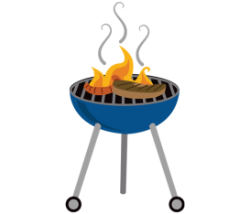 | 6:45 – 10:45 AM  1:30 – 5:30 PM Herbal & Essential oil Class@ 5:30 PM | 6:45-8:45 AM  4:00 – 6:00 PM | 6:45 – 10:45 AM  1:30 – 5:30 PM  YOGA CLASS 11:15AM | 6:45 – 10:45 AM  1:30 – 5:30 PM | DR AMANDA AND DR JILLIAN AT SEMINAR IN VIRGINIA BEACH  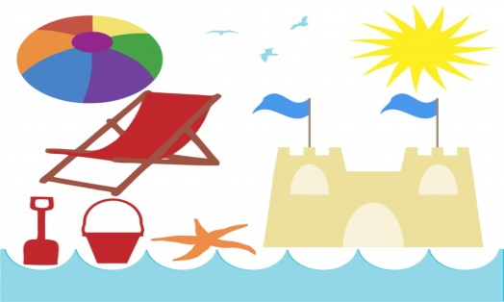
23 | 24  6:45 – 10:45 AM  1:30 – 5:30 PM Live Active life w/ Healthy low back@ 5:30 PM | 25  6:45-8:45 AM  4:00 – 6:00 PM | 26  6:45 – 10:45 AM  1:30 – 5:30 PM  YOGA CLASS 11:15AM | 27  6:45 – 10:45 AM  1:30 – 5:30 PM | 28 | 29

